“Hello, Good morning everybody, today we are going to do a crossfit class, not insane because, even us we can’t handle an insane class. So it’s gonna be easy don’t worry.

1- Move side to side “swinging the arms”counting 1 to 10 and after we move our foots behind, and finally with our hands in our body (15 times 2 repetitions all the time) (2-3min)

2- Squats. put your arms up, in front in you and then go down like the image and finally go up (10 times 2 repetitions) (3min)
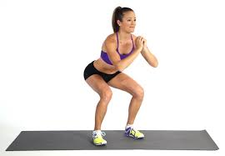
3- Lunge: Step forward with one leg, lowering your hips until both knees are bent at about a 90-degree angle. Make sure your front knee is directly above your ankle, not pushed out too far, and make sure your other knee doesn't touch the floor (15 times and 2 repititions) (2min)
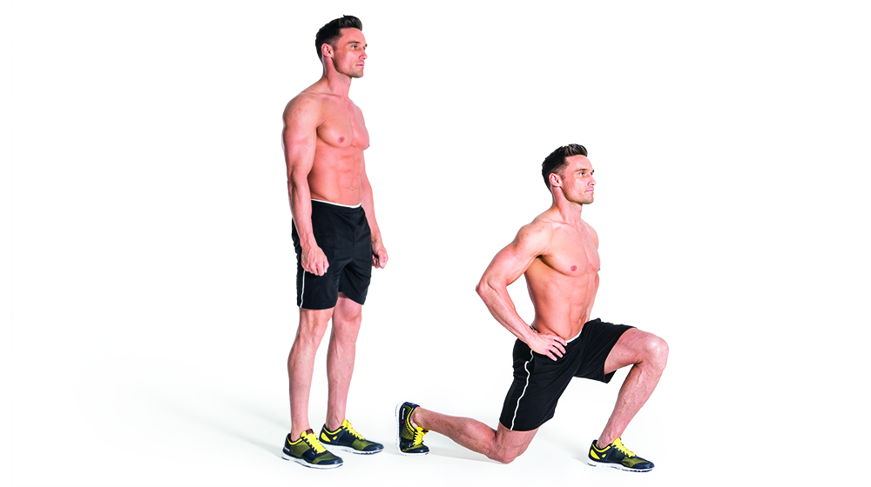

4- 3 types of abs. (body up, touching the heel y only legs side to side) (4min)

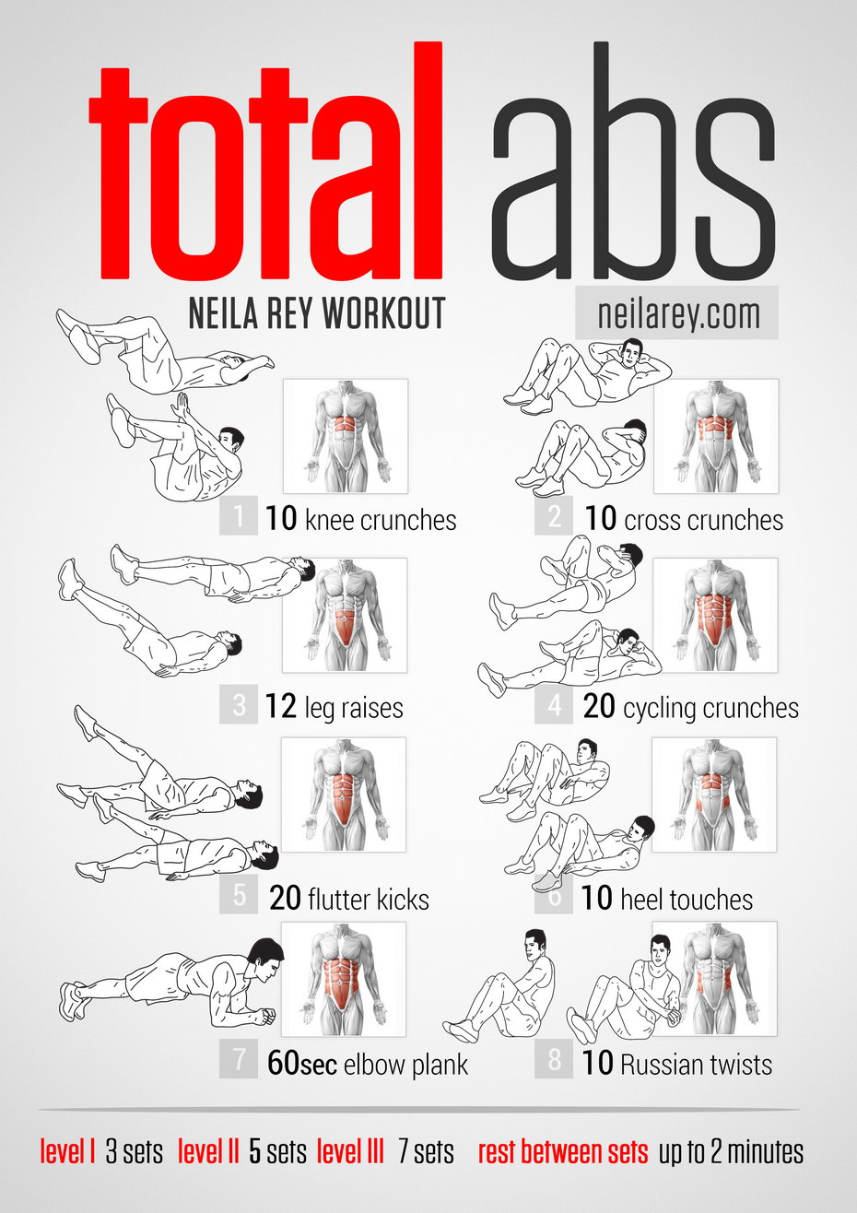

5- skipping. (2min)
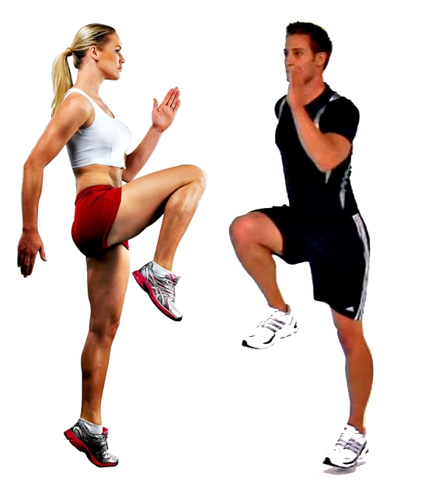

6. Side plank: 1min
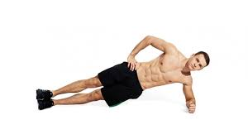
8. Push ups then up and jump clapping hands. (2min)

7.Planking 20 seg more or less, 5 repetitiones. lay down, put your hands in the floor and then make like the image (2min)
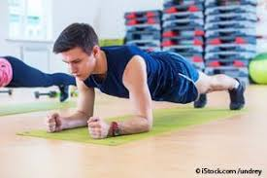

8. Jumping like kangaroos (leg up) (1 min)

9. Jumping rope. (3min)
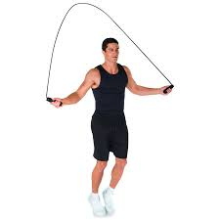

10. Superman: We stretch upside down and without our foot touching the ground we raise our hands. (2min)

11. first of all, make a squat, when you’re down stop and then open your legs and close (15 times 2 repititions) (2min)

